
Asia
Pacific Economic Cooperation
Climate
Center
Web site: www.apcn21.net
E-mail: apcn21@kma.go.kr
Tel: 82 2 836 6754
Fax: 82 2 832 6018

JOB OPENING

for

APCC RESEARCH SCIENTISTS

The APEC Climate Center (APCC) is seeking qualified research scientists in the areas of climate modeling, monitoring, prediction and application. APCC is aimed at producing reliable seasonal predictions to user communities, based on a multi-model ensemble climate prediction system. The principal objective is to establish a well-validated multi-model ensemble system (MMES) for the extended longer-term prediction to assist in the management of climate risks in the Asian-Pacific region.

Asia-Pacific Economic Cooperation (APEC) is the premier forum for facilitating economic growth, cooperation, trade and investment in the Asia-Pacific region.

Job duties include research and development in the areas of climate modeling, MME prediction, climate diagnostics, and application of climate information.

POSITION TITLE: Senior Research Scientist; Research Scientist;
Assistant Research Scientist; Supporting Scientist
JOB LOCATION: APCC, Busan, Korea
NATURE OF APPOINTMENT: One-year appointment with possible renewal
DEADLINE FOR APPLICATION: 5 August 2005
COMMENCEMENT OF DUTY: 1 September 2005

QUALIFICATIONS
- Senior Research Scientist
- Ph.D. in meteorology, atmospheric science or related physical science and more than five years of post-doctoral experience in climate modeling or diagnostics
- Research Scientist
- Ph.D. in meteorology, atmospheric science or related physical science and more than one year of post-doctoral experience in climate modeling or diagnostics
- Assistant Research Scientist
- MS in meteorology, atmospheric science or related physical science and more than three years of experience in climate modeling or diagnostics
- Supporting Scientist
- BS or MS in meteorology, atmospheric science or related physical science

OTHER REQUIREMENTS
- Excellent oral and written communication skills in English
- Scientific computing skills
- Ability to work as a team player in research and development

ANNUAL SALARY
- Salary depends on qualification, experience and skills.

APPLICATIONS
Applications with the following documents should be submitted by E-mail to the APCC Secretariat:
- Application form (download from APCN Homepage)
- A letter of interest
- Transcripts
- Three Recommendation letters (one for Supporting Scientist)

CONTACT
Ms. Ok-Ran Park
Tel: +82 2 836 6754
E-mail: apcn21@kma.go.kr
Homepage: www.apcn21.net
Please attach a recent photograph here. |  |  |  |  |  | 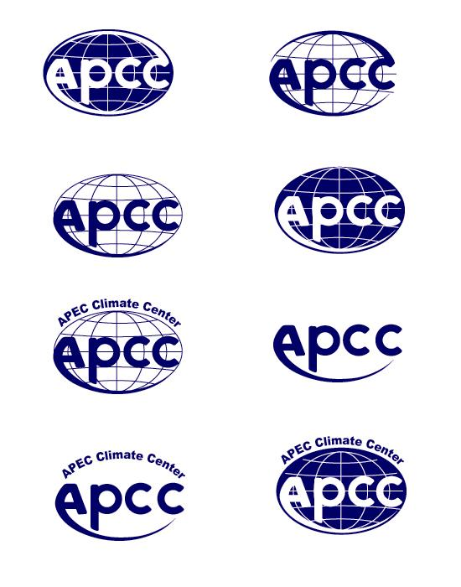  APEC Climate Center (APCC)  APPLICATION FORM |  |  |  |  |  |  |  |  |  |  |  |  |  |  |  | INSTRUCTIONS  Please answer each question clearly. Type or print in ink. Read carefully and follow all directions. If you need more space, attach additional pages of the same size.
1. Family name |  |  |  | Given name |  |  |  |  |  |  |  |  |  |  |  |  |  | Middle name |  |  |  |  |  |  |  | Maiden name (if applicable)
2. Present address and contact information (complete address, country; telephone and fax numbers; E-mail address)

3. Place of birth |  |  |  |  | Date of birth |  |  |  |  |  |  |  | Citizenship at birth |  |  |  |  |  |  |  |  |  |  | Present citizenship
4. Sex (check one) |  |  |  |  | 5. Marital status (check one)
Male □ |  | Female □ |  |  | Single □ |  |  |  |  |  | Married □ |  |  |  |  |  | Widow(er) □ |  |  |  |  |  | Divorced □ |  |  |  |  | Separated □
6. Knowledge of languages. Indicate your first language
Other languages |  |  |  |  | Reading and understanding |  |  |  |  |  |  |  |  |  | Writing |  |  |  |  |  |  |  |  |  | Speaking
 |  |  |  |  | Excellent |  |  | Good |  |  |  | Fair |  |  | Excellent |  |  |  |  | Good | Fair |  |  |  | Excellent |  |  | Good | Fair
7. Scientific computing skills and office machines you can use
8. Appointment is subject to satisfactory medical examination. Have you any disabilities which might limit your work?  (Medical Certificate should be submitted upon request.) |  |  |  |  |  |  |  |  | Yes □ No □ Explain:
9. EDUCATION
Name and place |  |  |  |  |  |  |  |  |  | Years attended |  |  |  |  |  |  |  |  | Degrees and Academic distinctions |  |  |  |  |  |  |  | Main subjects
 |  |  |  |  |  |  |  |  |  | From |  |  |  | To
10. EMPLOYMENT RECORD
Present or most recent work |  |  |  |  |  |  |  |  |  |  |  |  |  | Description of your work
From | To |  | Salaries per annum
(mm/yr) | (mm/yr) |  | Starting |  |  |  | Most recent
Exact title of your post
Name and address of employer
Name of supervisor
From | To |  | Salaries per annum |  |  |  |  |  |  |  |  |  |  | Description of your work
(mm/yr) | (mm/yr) |  | Starting |  |  |  | Final
Exact title of your post
Name and address of employer
Name of supervisor
From | To |  | Salaries per annum |  |  |  |  |  |  |  |  |  |  | Description of your work
(mm/yr) | (mm/yr) |  | Starting |  |  |  | Final
Exact title of your post
Name and address of employer
Name of supervisor

11. Have you ever been arrested, indicted or summoned into court as a defendant in a criminal proceeding, or convicted , fined or imprisoned for the violation of any law (excluding minor traffic violations)? Yes □ No □
If answer is “Yes”, give full particulars of each case in an attached statement.
12. References: List three persons who are familiar with your character and qualifications.
Full name | Full address including telephone number and E-mail address
1.
2.
3.
13. You are applying for: | Expected salary per annum
□ Senior Research Scientist
□ Research Scientist
□ Assistant Research Scientist
□ Supporting Scientist
14. In the event of being selected, how much notice would you need before taking up an appointment?
15. State any other facts which, in your opinion, might help in evaluating your application (e.g., activities of an international character, significant publications (please attach), etc.)
16. You will be requested to supply documentary evidence that supports the above statement. DO NOT, however, send any documents until you have been requested to do so by the APCC Secretariat.
Tel: +82 2 836 6754
Fax: +82 2 832 6018
E-mail: apcn21@kma.go.kr
Homepage: www.apcn21.net
APCC Secretariat
Korea Meteorological Administration
460-18, Shindaebang-dong, Dongjak-gu
Seoul, 156-720, Korea.

17. I certify that the statements made by me in answer to the forgoing questions are true, complete and correct to the best of my knowledge and belief. I understand that any misrepresentations or material omission made on the APPLICATION FORM or other document requested by APCN renders a staff member of APCN liable to dismissal.

Date Signature

